Alvie P. Teeter
December 1, 1891 – April 1, 1983

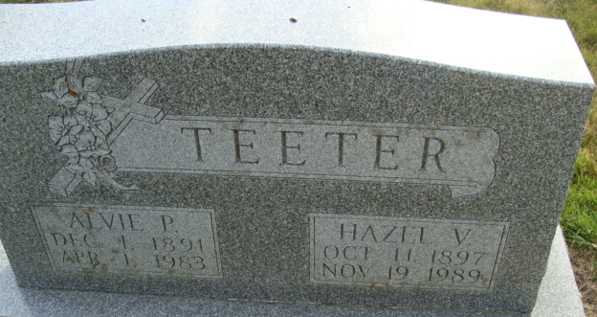
Photo by Alicia Kneuss

Alvie Teeter
in the Indiana, U.S., Death Certificates, 1899-2017
Name Alvie Teeter
Gender Male
Race White
Marital Status Married
Age 91
Birth Date 1 Dec 1891
Birth Place Indiana
Death Date 1 Apr 1983
Death Place Berne, Adams, Indiana, USA
Death Registration Date 1983
Father John Teeter
Mother Martha Ann Baker
Spouse Hazel Springer
Informant Mrs. Reba Gerber; Geneva, Indiana
Burial April 5, 1983; Decatur Cemetery; Decatur, Indiana

