Sarah Olivia (Willis) Teeple
February 18, 1883 – July 6, 1971

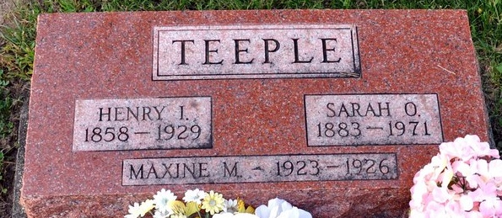
Photo by Deb Curry

Mrs. Sarah Teeple Dies at Bluffton
Mrs. Sarah Olivia Teeple, 88, of Craigville, Route 1, widow of Henry Irvin Teeple, died at 5:30 p.m. Tuesday at the Wells Community Hospital at Bluffton, where she had been a patient three weeks.
She was born in Flatrock, Ill., Feb. 18, 1883, a daughter of Ezra and Luzetta Vernon-Willis. She formerly lived east of Monroe for 10 years. Her husband preceded her in death in 1929.
Mrs. Teeple was a member of the Tocsin United Methodist Church and the Ladies Aid Society of the church.
Surviving are a son, Harvey Teeple of Berne Route 1; two daughters, Mrs. Amos (Rosalene) Hirschy of Monroe Route 1, and Mrs. James (Irene) Lynch of Sun Valley, Calif.; a stepdaughter, Mrs. Ed (Ruby) Hart of Fort Wayne; two stepsons, Oscar Teeple of Monroe Route 1, and Albert Teeple of Elida, O; two brothers James Willis of Flatrock, Ill, and Charles Willis of Beatyville, Ky.; two sisters, Mrs. Anna Green of Normal, Ill., and Miss Effie Willis of Flatrock, Ill; 11 grandchildren and 13 great-grandchildren.
Services will be held at 2 p.m. Friday at the Tocsin United Methodist Church, with Rev. Bruce Kenline officiating. Burial will be in the Decatur Cemetery. Friends may call at the Elzey Funeral Home in Ossian after 7 p.m. today.

Decatur Daily Democrat, Adams Co, Indiana
Wednesday, July 7, 1971

