Samuel Oscar Teeple
November 4, 1890 – September 24, 1973

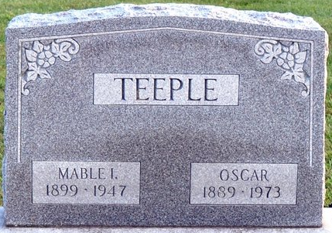
Photo by Deb Curry

OSCAR TEEPLE, 82, DIES AT CARE CENTER
Oscar Teeple, 82, of route 1, Monroe, a retired farmer, died at 5:25 a.m. this morning at the Decatur Community Care Center. He had been a patient there since May 3.
He was a member of American Legion Adams Post 43; D.A.V.; and Veterans of World War I.
Born in Van Wert County, O., on Nov 4, 1890, he was the son of Henry I. and Rebecca Miller-Teeple, and was married to Mabel I. Cottrell, who preceded him in death on April 16, 1947.
Surviving are one daughter, Mrs. Frank (Rebecca) Wales of Fort Wayne; two brothers, Albert Teeple of Elida, O., and Harvey Teeple of Berne; and one granddaughter, Cindy Wales. Four sisters and one brother preceded him in death.
Funeral services will be held at 3:30 p.m. Wednesday at the Zwick funeral home, with Rev. Otto Busse officiating. Burial will be in the Decatur cemetery. Friends may call at the funeral home after 12 noon Tuesday. Full military services will be conducted by the American Legion Post 43.
Decatur Daily Democrat, Adams County, Indiana
Monday, September 24, 1973

**
Indiana Marriage Collection, 1800-1941
Name: Samuel O Teeple Spouse Name: Mable I Cottrell
Marriage Date: 3 Oct 1819 Marriage County: Adams
Source: Adams County, Indiana Index to Marriage Records 1845 - 1920 Inclusive Vo; W. P. A. Original Record Located County Clerks Off; Book: K, OS Page: 580
**
Granted Marriage License (Special to the News)
DECATUR, Ind., Oct. 4.- A marriage license was issued to Samuel Oscar Teeple, of Blue Creek township, born October 4, 1889, son of Henry L. Teeple, to wed Mabel Inez Cottrell, born October 12, 1899, daughter of Clarence Cottrell.

Fort Wayne News and Sentinel, Allen County, Indiana
Saturday October 4, 1919

