Ruth I. (Conner) Teeple
December 11, 1891 – September 5, 1964

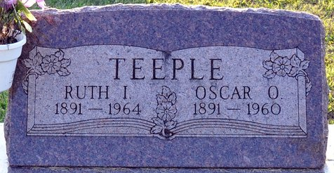
Photo by Deb Curry

Mrs. Ruth Teeple
Word has been received of the death of Mrs. Ruth (Connor) Teeple, 73, of Decatur, Ind. She was the sister of Morris Connor of 405 S. McDonel.
She was born in Alger, the daughter of Ezra and Lucinda Connor, and resided in Lima from 1922 to 1924.
Two other brothers, a son and a daughter also survive.
Funeral services will be at 1:30 p.m. Tuesday in Decatur.
The Lima News, Allen County, Ohio
Sunday, Sept. 6, 1964
**
Indiana, U.S., Death Certificates, 1899-2017
Name Ruth Teeple
[Ruth Conner]
Gender Female
Race Caucasian (White)
Marital Status Widowed
Age 72
Birth Date 11 Dec 1891
Birth Place Ohio
Death Date 5 Sep 1964
Death Place Decatur, Adams, Indiana, USA
Death Registration Date 1964
Father Ezra B Conner
Mother Cina V Shockey
Informant Mrs. Lenore Lytle; daughter; Decatur, Indiana
Burial September 8, 1964; Decatur Cemetery; Decatur, Indiana

