Rebecca Ellen (Miller) Teeple
December 22, 1855 – October 8, 1919

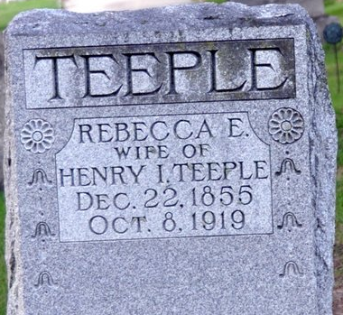
Photo by Deb Curry

Mrs. Teeple Dead
Mrs. Rebecca Ellen Teeple Passed Away Today at 6:25 a.m. at Home
South of Salem - Was Sixty-three Years of Age
Bedfast a Week - Well Known Lady
Mrs. Henry I. Teeple, aged sixty-three, died this morning at 6:25 o'clock at her home in Blue Creek Township, a mile south of Salem. Death was due to cancer of the kidney and while she had been ailing for a long time, she was bedfast only a week.
Rebecca Ellen Miller, daughter of Robert and Rachel Nix Miller, was born in Ohio, December 22, 1855, making her at death, sixty-three years, nine months and sixteen days of age. She was long a resident of this county, and one of the prominent ladies of her community.
A number of children survive. A daughter, Mrs. Lula Welch, passed away only last June 4.
The funeral will be held Friday afternoon, leaving the home at 2:30 o'clock for the Pleasant Mills Methodist Church. Burial will be in the Decatur Cemetery.
Decatur Daily Democrat, Adams County, Indiana
Wednesday, October 8, 1919

