Raymond D. Teeple
August 4, 1922 – December 6, 2008

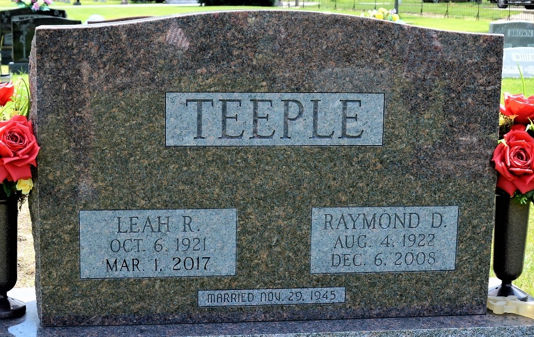
Photo by Deb Curry

Raymond D. Teeple, 86, a resident of Craigville, died at 6:40 p.m. on Saturday, December 6, 2008 at Bluffton Regional Medical Center following an extended illness.
He was born on August 4, 1922, in Adams County, to Albert and Leona (Bartling) Teeple. He was married on November 29, 1945 to Leah Ruth Rash.
Visitation is from 2:00 to 4:00 p.m. and 5:00 to 8:00 p.m. on Tuesday, December 9 at Zwick and Jahn Funeral Home, and one hour prior to the 1:30 p.m. service on Wednesday, December 10 at the funeral home. Officiating is Pastor Mike Gilbert. Burial will be in Decatur Cemetery with military graveside rites by American Legion Post #43.
The Berne Tri-Weekly News, Adams County, Indiana
Monday, December 8, 2008
**
Raymond D. Teeple, 86 years old of Craigville, Indiana, went home to be with his Lord and Savior on Saturday, December 6, 2008 at the Bluffton Regional Hospital following an extended illness.
He was born on Friday, August 4, 1922 in Adams County, Indiana the son of Albert and Leona (Bartling) Teeple. He married Leah Ruth Rash on November 29, 1945 in Richmond, Indiana.
Raymond served in WWII in the United States Army as an MP and was stationed in France, Germany & Italy. He worked at General Electric in Decatur for 43 years before retiring in 1986 and was also a Wells County, Lancaster Township farmer. He worked with Habitat for Humanity in Wells County and faithfully attended the Murray Missionary Church in Murray, Indiana.
Surviving are his wife, Leah Ruth Teeple of Craigville, daughter, Mrs. Kevin (Cheryl) Crist of Bluffton, daughter, Mrs. Phillip (Carol) Fosnaugh of Keystone, daughter, Mrs. Tom (Connie) Archbold of Paulding, Ohio, son, Richard (Carol) Teeple of Ossian, son, Raymond Phil (Kathy) Teeple of Liberty Center, daughter, Mrs. Dee (Deb) Blair of Craigville, brother, Robert M. Teeple of Decatur, sister, Esther M. Adams of Berne, sister, Zella M. Haines of Decatur, brother, Albert Teeple Jr. of Sun City West, Arizona, sister, Patricia M. Marks of Sun City West, Arizona, fifteen grandchildren and eighteen great-grandchildren.
Preceding Raymond in death were one grandson, Jared Matthew Teeple, two brothers, Donald Wayne & Richard Teeple and two sisters, Geraldine Lauck & Jessie Grepke.
Funeral services will be held at 1:30 p.m. Wednesday, December 10, 2008 in the Zwick & Jahn Funeral Home with Pastor Mike Gilbert officiating. Interment will follow in the Decatur Cemetery with Military Graveside services conducted by American Legion Post #43 of Decatur. Friends will be received from 2:00 p.m. to 4:00 p.m. and 5:00 p.m. to 8:00 p.m., Tuesday, December 9 in the Zwick & Jahn Funeral Home and one hour prior to the service on Wednesday at the funeral home.
Preferred memorials are to Murray Missionary Church or Habitat for Humanity.

Zwick & Jahn Funeral Home, Adams County, Indiana
December 7, 2008

