Ray Z. Teeple
October 8, 1889 – October 25, 1942

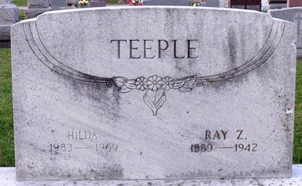
Photo by Deb Curry

Ray Z. Teeple, 53, claims agent for the Pennsylvania Railroad in the Fort Wayne, Ind. district, which includes Lima, died suddenly Sunday afternoon at Ft. Wayne of a heart attack.
Teeple had been in railroad work for 36 years and was well known in Lima. He was employed by the Erie Railroad for several years before joining the Pennsylvania legal department.
He was a native of Decatur, Ind., and had lived in Ft. Wayne since 1918.
Surviving are his wife and one son.
The Lima News, Van Wert County, Ohio
Monday, October 26, 1942
**
Indiana, U.S., Death Certificates, 1899-2017
Name Ray Z Teeple
Gender Male
Race White
Marital Status Married
Age 53
Birth Date 8 Oct 1889
Birth Place Decatur, Indiana
Death Date 25 Oct 1942
Death Place Fort Wayne, Allen, Indiana, USA
Death Registration Date 1942
Father Judson W Teeple
Mother Maggie Ziegler
Spouse Hilda E
Informant Mrs. Hilda Teeple; Fort Wayne, Indiana
Burial October 28, 1942; Maplewood Cemetery; Decatur, Indiana

