Oscar O. Teeple
February 4, 1891 – March 22, 1960

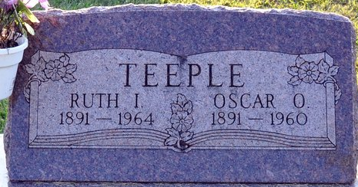
Photo by Deb Curry

Oscar Teeple Dies Tuesday Afternoon
Oscar O. Teeple, 69, of 417 North Third Street, lifelong resident of Adams County, died at St. Joseph hospital in Fort Wayne. He had been hospitalized 10 days and underwent surgery Monday.
He was born in Adams County Feb. 4, 1891, a son of Oscar and Ida Ayres-Teeple, and was married to Ruth Conner Aug. 15, 1912.
Mr. Teeple was employed at the Decatur plant of the General Electric Co. for 35 years prior to his retirement in 1955.
Surviving are his wife; one daughter, Mrs. Dwight (Lenore) Little of Decatur; one son, Charles W. Teeple of Fort Pierce, Fla.; three grandchildren; seven great-grandchildren; two half-brothers, Paul Newberry of Grand Rapids, Mich., and Hearl (sic) Newberry of Detroit, Mich., and two step-brothers, Clarence Chronister of Wren, O., and Milton Chronister of Bobo.
Funeral services will be conducted at 2 p.m. Friday at the Zwick funeral home, the Rev. F. Hazen Sparks officiating. Burial will be in the Decatur Cemetery. Friends may call at the funeral home at 7 o'clock this evening until time of the services.
Decatur Daily Democrat, Adams County, Indiana
Wednesday, March 23, 1960

