Minnie E. (Gay) Teeple
June 30, 1868 – October 8, 1958

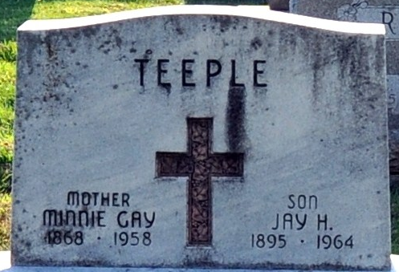
Photo by Deb Curry

Mrs. Minnie Teeple Dies Last Evening
Decatur Lady Dies After Long Illness
Mrs. Minnie Teeple, of 510 Closs Street, well known Decatur lady, died at 6:30 o'clock Wednesday evening at the Berne Nursing Home, following an illness of three months. Mrs. Teeple celebrated her 90th birthday June 30.
She was born in Bucyrus, O., June 30, 1868, a daughter of Andrew and Elizabeth Stewart-Gay, and had resided in Decatur for the past 50 years.
Mrs. Teeple was a member of the Bethany Evangelical United Brethren Church, the Rebekah Lodge, Pythian Sisters, the Decatur Home Demonstration Club and the American Legion Auxiliary.
Surviving are two daughters, Mrs. J. E. (Nellie) Rutledge of Lima, O., and Mrs. Lillie DeWitt of Indianapolis; four sons, Jay A Teeple of Danville, Ill., Max H. Teeple of Bluffton, John E. Teeple of Maumee, O., and Jacks S. Teeple of Decatur; one stepson, Harvey J. Teeple of Decatur; 10 grandchildren and 14 great-grandchildren. One daughter, one stepson, one brother and one sister preceded her in death.
Funeral services will be conducted at 2 p.m. Saturday at the Zwick Funeral Home, with the Rev. Benj. G. Thomas officiating. Burial will be in the Decatur Cemetery. Friends may call at the funeral home after 7 o'clock this evening until time of the services.
Decatur Daily Democrat, Adams County, Indiana
Thursday, October 9, 1958

