Maxine M. Teeple
October 17, 1923 – April 19, 1926

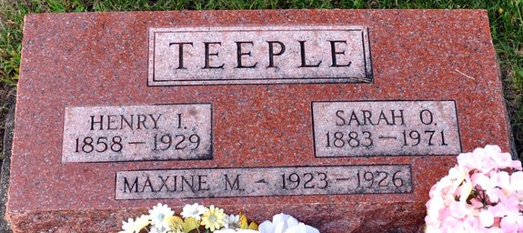
Photo by Deb Curry

Maxine Tufle
in the Indiana, U.S., Death Certificates, 1899-2017
Name Maxine Teeple
Gender Female
Race White
Marital Status Single
Age 2
Birth Date 17 Oct 1923
Birth Place Blue Creek Tp Adams Co Indiana
Death Date 19 Apr 1926
Death Place Blue Creek, Adams, Indiana, USA
Death Registration Date 1926-1927
Father Henry Irvin Teeple
Mother Sarah Olivia Willis
Informant H. I. Teeple; Decatur, Indiana
Burial April 20, 1926; Decatur Cemetery

