Maurice E. Teeple
June 25, 1925 – January 14, 2014

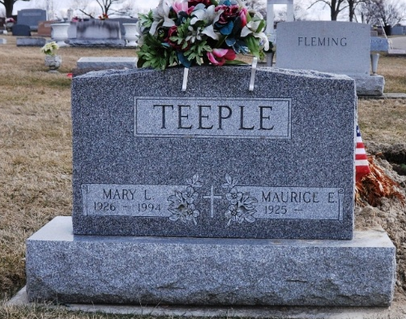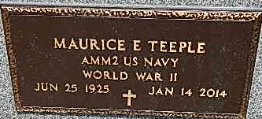
Photo by Deb Curry Photo by Alicia Kneuss

Maurice E. “Maury” Teeple, 88, of Decatur, IN passed away on Tuesday, January 14, 2014 at Adams Memorial Hospital. He was born on June 25, 1925 in Decatur to the late Fred E. and Iva A. (Barrone) Teeple. On January 26, 1946 he married Mary L. Whitaker; she died on August 24, 1994. He was a member of St. Mark’s United Methodist Church, where he served on most of the various boards.
He faithfully served his country in the U.S. Navy during WWII and was a member of the American Legion Post 43. Maury worked for G.E. in Decatur, the Decatur Police Department, he was the owner and operator of Decatur Blue Flame, and retired from First State Bank in 1984. Maury was a member of the Decatur Masonic Lodge 571 F. & A.M. for over 50 years, Ancient Accepted Scottish Rite Valley of Fort Wayne and the Mizpah Shrine. He was also the last living charter member of the Decatur Optimist Club, where he served as the president, secretary, treasurer and lieutenant governor for this district. He was a retired volunteer firefighter in Decatur for 52 years.
He is survived by a son Gary E. (Joyce) Teeple of Decatur; 3 daughters Cheryl (William) Bowers of Monroeville, Sonya (Joe) Myers of Hamilton, and Julie (Chris) Blauvelt of Monroeville; a brother James (Clara Lou) Teeple of Monroe; 14 grandchildren and 32 great grandchildren. He was also preceded in death by 3 step brothers Jack, Jim and Bill Hunter and a great grandson Ethan Teeple.
Visitation will be from 11:00 a.m. – 5:00 p.m. on Sunday, January 19, 2014 at Haggard-Sefton & Hirschy Funeral Home with a Masonic Service at 5:00 p.m. followed by an Optimist Memorial Service and a walk through by the Decatur Fire Department. Funeral Service will be held at St. Mark’s United Methodist Church at 11:00 a.m. on Monday, January 20, 2014 with calling 1 hour prior the service with The Reverend Phil Emerson officiating. Burial will follow in the Decatur Cemetery with Military Graveside Rites by the America Legion Post 43 Color Guard. In lieu of flowers, please make donations to St. Mark’s United Methodist Church or Riley Children’s Hospital.

Haggard-Sefton & Hirschy Funeral Home, Adams County, Indiana

