Mary F. Teeple
September 9, 1862 – March 4, 1876

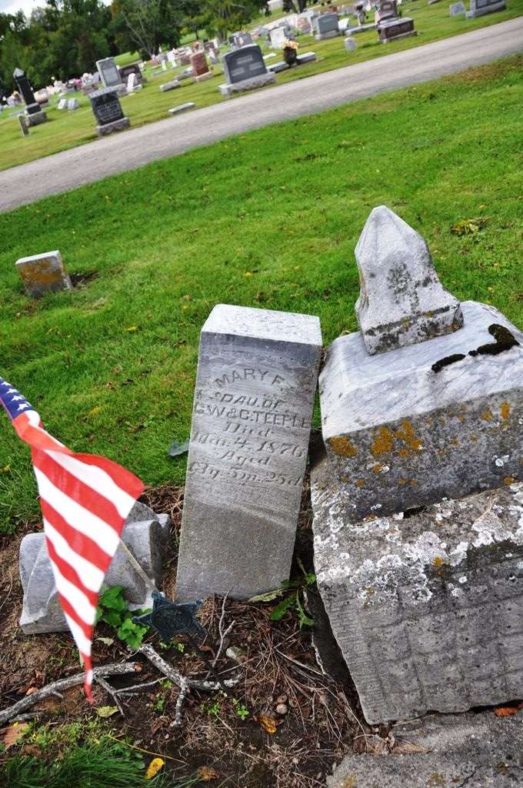
Photo by Deb Curry

From Maplewood burials, Decatur (IN) library:
Teeple, Mary F., dau of G. W. and C. Teeple, died May 4, 1876, age 13 yrs, 5 mo, 25 da
**
Mary F Teeple from tree Adams & Ross (Restored) 01-09-2014
Birth 9 Sep 1862 Adams, Indiana, USA
Residence 1870 Allen, Indiana, USA
Death 4 Mar 1876 Decatur, Adams, Indiana, USA
Father George Washington Teeple (1834-1916)
Mother Catharine Brittsan (1837-1879)

