Mary E. (Komp) Teeple
August 17, 1877 – January 19, 1944

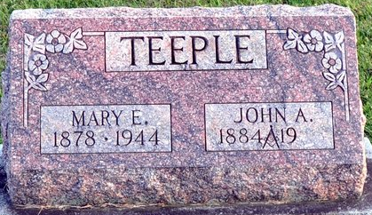
Photo by Deb Curry

Mary E Teepell
in the Indiana, U.S., Death Certificates, 1899-2017
Name Mary E Teeple
[Mary E Komp]
Gender Female
Race White
Marital Status Married
Age 66
Birth Date 17 Aug 1877
Birth Place Kosciusko County
Death Date 19 Jan 1944
Death Place Fort Wayne, Allen, Indiana, USA
Death Registration Date 1944
Father Daniel Komp ?
Spouse John A Teeple; age 58
Informant John A. Teeple; Fort Wayne, Indiana
Burial January 21, 1944; Maplewood Cemetery; Decatur, Indiana

