Margaret (Fordyce) Teeple
April 19, 1878 – July 21, 1961

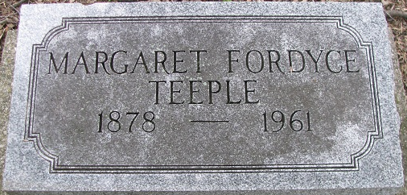
Photo by Deb Curry

MRS CHARLIE TEEPLE DIES LAST EVENING
Mrs. Margaret Teeple, 83, of 504 North Second Street, prominent in church and civic activities here for many years, died suddenly at 8:30 Friday evening at the Adams County Memorial Hospital shortly after being admitted. She had not been ill and death was unexpected.
Mrs. Teeple was the widow of Charlie Dailey Teeple, who was engaged in the men's clothing business for many years before his death Jan. 12, 1951. She was born in Washington Township April 19, 1878, a daughter of Simeon B. and Mary Ellen Brandyberry-Fordyce, and lived here her entire life except for five years when she resided at St. Joseph, Mich. She graduated from the Decatur High School in 1897, and was married May 27, 1898.
Mrs. Teeple was highly active in all groups of the First Presbyterian Church, and was one of the first women in the state to serve as an elder. She taught in the Sunday school for many years. She was also a member of the Order of Eastern Star and was a past president of the Shakespeare Club.
She is survived by one daughter, Mrs. Theodore T. (Alta) McClintock of Cincinnati, O; three grandchildren, Mrs. William Black of Wheaton, Ill., Mrs. John P. Halstead of East Aurora, N.Y., and Lt. Andrew Fordyce McClintock of Ft. Jackson, S. C., and three great-grandsons.
Funeral services will be conducted at 2 p.m. Monday at the Zwick Funeral Home, the Rev. Lazlo Polyak officiating. Burial will be in the Decatur Cemetery. Friends may call at the funeral home after 7 p.m. today until time of the services.
Decatur Daily Democrat, Adams County, Indiana
Saturday, July 22, 1961

