Maggie E. Teeple
May 17, 1868 – June 17, 1888

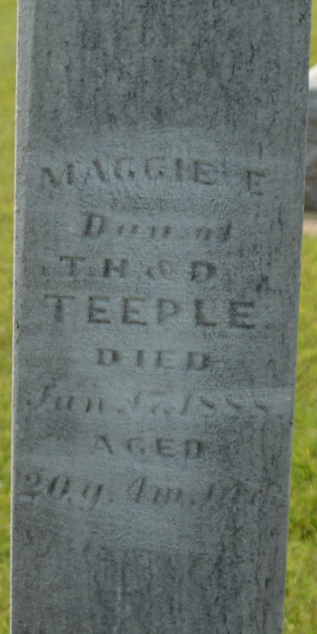
Photo by Deb Curry

Maggie E. Teeple from tree Hoopingarner (Indianapolis)
Birth 17 May 1868 Ohio, USA
Residence 1880 Willshire, Van Wert, Ohio, USA
Death 17 Jun 1888 Modesto, Stanislaus, California, USA
Father Thomas Henry Teeple (1847-1917)
Mother Delana Springer (1845-1911)

