Maggie A. (Zeigler) Teeple
September 28, 1858 – May 8, 1927

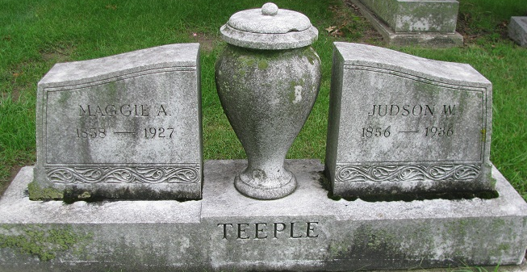
Photo by PLS

MRS. JUDSON TEEPLE DIES
Wife of Former Mayor of Decatur Dies at Home Here Early This Morning
Mrs. Maggie A. Teeple, 68, wife of Judson W. Teeple, former mayor of Decatur, died at her home at 706 North Second Street, at 6:50 o'clock this morning following an extended illness due to goiter and heart trouble.
Mrs. Teeple fell more than seven months ago and dislocated one of her arms and she had never been out of her home since that time.
Maggie Ziegler Teeple was a daughter of Peter and Leah Ziegler and was born in Center County, Pennsylvania, September 28, 1858. She was married to Judson W. Teeple at East Germantown (new Pershing), Indiana, May 28, 1885. Since their marriage, Mr. and Mrs. Teeple have resided in Decatur, Mr. Teeple having been admitted to the Adams County Bar previous to their marriage.
Three children were born to Mr. and Mrs. Teeple, one of whom, Ray Z. Teeple, of Fort Wayne, survives. The other two, Erie May and Roy Smith Teeple, died several years ago. One brother survives in addition to the husband and one son. He is Lyman H. Ziegler, of Redkey. Mrs. Teeple was a member of the Evangelical church at Pershing.
Funeral services will be held at the residence at 2 o'clock Wednesday afternoon, with the Rev. H.W. Thompson, pastor of the Christian Church, officiating. Burial will be made in the Decatur Cemetery.
Decatur Democrat, Adams County, Indiana
Monday, May 9, 1927
**
Indiana, U.S., Death Certificates, 1899-2017
Name Maggie A. Teeple
[Maggie A. Zeigler]
Maiden Name Zeigler
Gender Female
Race White
Marital Status Married
Age 70
Birth Date 28 Sep 1856
Birth Place Pennsylvania
Death Date 8 May 1927
Death Place Decatur, Adams, Indiana, USA
Death Registration Date 1926-1927
Father Peter Zeigler
Mother Leah Ruhl
Spouse Judson N. Teeple
Informant Ray Teeple; Fort Wayne, Indiana
Burial May 11, 1927; Decatur Cemetery

