Mable I. (Cottrell) Teeple
October 12, 1899 – April 16, 1947

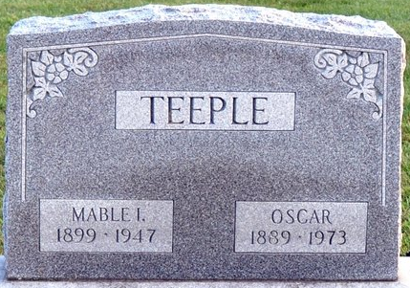
Photo by Deb Curry

MRS. MABEL TEEPLE DIES THIS MORNING
Funeral Services Saturday Afternoon
Mrs. Mabel I. Teeple, 47, of near Salem, and a lifelong resident of Blue Creek Township, died at 1:05 o'clock this morning at the Adams County Memorial Hospital. She had been ill for two years and critical for the past five years.
She was born in Adams County October 12, 1899, a daughter of Clarence and Maggie Burdg-Cottrell. She was married to Oscar Teeple October 3, 1919.
She was a member of the Union U. B. Church.
Surviving in addition to the husband are a daughter, Miss Rebecca C. Teeple of Fort Wayne; one sister, Mrs. Daniel Barnhart of Fort Wayne, and a number of nieces and nephews.
Funeral services will be held at 1:30 p.m. Saturday at the home, one mile north of Salem, and at 2 o'clock at the Union U. B. Church, with the Rev. Marks and the Rev. C. E. Roberts officiating. Burial will be in the Decatur Cemetery. The body will be moved from the Zwick Funeral Home to the residence at 2 p.m. Thursday.
Decatur Daily Democrat, Adams County, Indiana
Wednesday, April 16, 1947

