Lula A. (Davidson) Teeple
May 15, 1882 – December 25, 1962

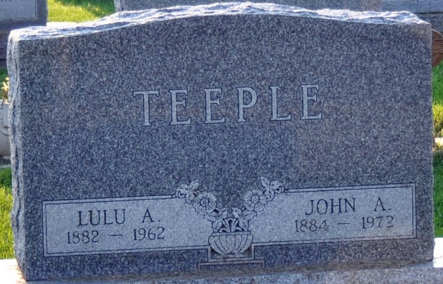
Photo by Deb Curry

Mrs. Lula Teeple Is Taken By Death
Mrs. Lula A. Teeple, 80, wife of John A. Teeple of Blue Creek Township, route 1, Rockford, 0., died at 12:15 p.m. Tuesday at the Gibbons Hospital in Celina, O., where she had been a patient two weeks. She had been bedfast for the past two years.
She was born in Pittsburgh, Kan., May 15, 1882, a daughter of Andrew S. and Ada M. Walker-Davidson and lived in Fort Wayne most of her life. Her first, husband, Henry Brandt, died in 1940. She was married to John A. Teeple in 1949.
Mrs. Teeple was a member of the Calvary Evangelical United Brethren Church at Fort Wayne for 50 years.
Surviving in addition to her husband are one brother, Clifford C. Davidson of Columbus, O.;. Two sisters, Mrs. Harry (Emma) Brown and Mrs. Roy (Hazel) Davies, both in Decatur, and a niece, Mrs. Harry (Lucille) Schube of Columbus, O.
Funeral services will be held at 10:30 a.m. Friday at the Zwick Funeral Home, the Rev. Delbert E. Cress officiating. Burial will be in the Decatur Cemetery. Friends may call at the funeral home after 7 p.m. today until time of the services.
Decatur Daily Democrat, Adams County, Indiana
Wednesday, December 26, 1962

