Lillie V. Teeple
December 20, 1886 – April 30, 1960

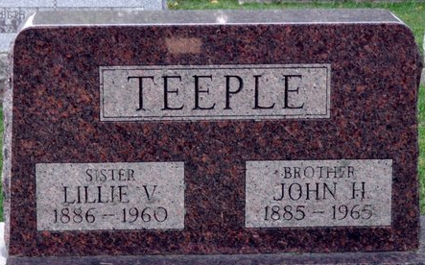
Photo by Deb Curry

Lillie V Teeple
in the Indiana, U.S., Death Certificates, 1899-2017
Name Lillie V Teeple
Gender Female
Race White
Marital Status Never Married (Single)
Age 73
Birth Date 20 Dec 1886
Birth Place Indiana
Death Date 30 Apr 1960
Death Place Bluffton, Wells, Indiana, USA
Death Registration Date 1960
Father Henry J Teeple
Mother Rebecca A Miller
Informant John H. Teeple; brother; Decatur, Indiana
Burial May 3, 1960; Decatur Cemetery; Decatur, Indiana

