Leah (Rash) Teeple
October 6, 1921 – March 1, 2017

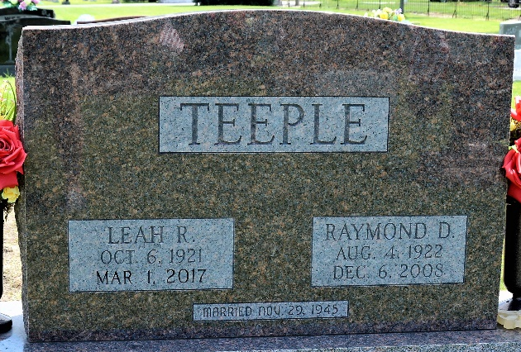
Photo by Deb Curry

Leah R. Teeple, 95, a former resident of Craigville, went home to be with her Lord and Savior on Wednesday, March 1, 2017 at 7:20 a.m. in the Christian Care Retirement Community in Bluffton.
Leah was born on October 6, 1921 in Willshire, Ohio to Philip and Florence (Koos) Rash. Following graduation from Bryant High School in 1939 she began working at GE in Decatur, where she met a man by the name of Raymond Teeple. They were united in marriage on November 29, 1945 after Raymond was honorably discharged from the United States Army following World War II. Their marriage was blessed with six children and Leah devoted her time to being a homemaker and mother. Raymond preceded Leah in death on December 6, 2008.
In addition to her calling as a mother, Leah was involved with her church and supporting its mission. She was also a member of the Wells County Homemakers Club and named Homemaker of the year in 2002.
Leah is survived by her children: daughter, Cheryl (Kevin) Crist of Bluffton, IN; daughter, Carol (Phillip) Fosnaugh of Keystone, IN; daughter, Connie (Tom) Archbold of Paulding, OH; son, Richard (Carol) Teeple of Bluffton, IN; son, R. Phil (Kathy) Teeple of Ossian, IN; daughter, Debbie (Dee) Blair of Craigville, IN; sister, Laura Stephen of Ft. Wayne, IN; and sister Marie Whetzel of Dunkirk, IN; 15 grandchildren; and 32 great-grandchildren.
Leah was preceded in death by a grandson: Jared Teeple; 2 brothers: Philip Rash and John Rash; and one sister: Helen Boise.
A Celebration of Life Service will be held for Leah at 2:00 p.m. on Monday, March 6, 2017 in the Zwick & Jahn Funeral Home – Decatur with Pastor Mike Gilbert officiating. Following the service, Leah will be buried next to her husband, Raymond, in Decatur Cemetery. Friends and family will be received from 12 Noon to 6:00 p.m. Sunday in the Zwick & Jahn Funeral Home – Decatur and one hour prior to services Monday also at the funeral home.
Preferred memorials in memory of Leah can be made to the Murray Missionary Church.

Zwick & Jahn Funeral Home, Adams County, Indiana
March 2, 2017

