Julius Franklin Teeple
April 11, 1916 – September 15, 1985

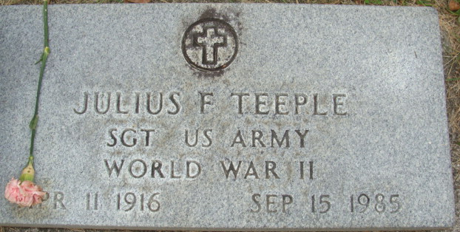
Photo by PLS

Julius F. Teeple, 69, of R. 1, Wolcottville, died at McCray Hospital Sunday. He was born in Decatur April 11, 1916 to David F. and Agnes (Reardon) Teeple. On Feb. 15, 1947 in Decatur he married Goldie Franz.
He moved to Big Long Lake from Decatur 10 years ago and was retired as vice president of Teeple Truck Lines Inc.
A veteran of WW II, he was a member of St. Mary’s Catholic Church, LOOM No. 1311, American Legion Post 43 and BPOE No. 993, all of Decatur; and VFW Post 2749 in Kendallville.
Surviving is his wife; a daughter, Cynthia L. Yoquelet of Wolcottville; 2 sons, Stephen M. of Bradenton, Fla., and Jeffrey L., Avilla; 3 sisters, Marcella Kintz and Mildred White of Sarasota, Fla., and Patricia Klepper of Lima, Ohio; 3 brothers, Les A., Anthony E., and Edward A. of Decatur; and 6 grandchildren. A brother, 4 sisters and 2 half-sisters preceded him in death.
Services will be on Wednesday at Berhalter-Hutchins Funeral Home, Kendallville. Graveside services will be Wednesday in Decatur Cemetery

Unknown source

**
Indiana, U.S., Death Certificates, 1899-2017
Name Julius Franklin Teeple
Gender Male
Race White
Marital Status Married
Age 69
Birth Date 11 Apr 1916
Birth Place Indiana
Death Date 15 Sep 1985
Death Place Kendallville, Noble, Indiana, USA
Father David Franklin Teeple
Mother Agnes Reardon
Spouse Goldie Franz
Informant Goldie Teeple; wife; Wolcottville, Indiana
Burial September 18, 1985; Decatur Cemetery; Decatur, Indiana

