Judson W. Teeple
October 29, 1856 – July 9, 1936

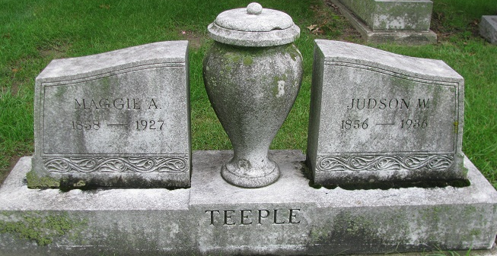
Photo by PLS

TEEPLE RITES SET FOR SUNDAY
Former Decatur Mayor and Attorney Dies Suddenly of Heart Attack
(Special to the Journal-Gazette)
Decatur, July 10 – Judson W. Teeple, 79, former mayor of Decatur, died suddenly Thursday night at the Ellis apartment on South Second Street. Friend and legal adviser to the Ellis family, he called at the apartment but complained of feeling ill. He suffered a heart attack a few minutes after arriving at the apartment and efforts to revive him were futile. Coroner Robert Zwick said death was caused by angina pectoris, superinduced by the extreme heat.
Mr. Teeple was mayor from 1909 to 1913 after serving four years on the city council. He was prominent in Republican political activities and an active member of the Adams County Bar Association, of which he was the second oldest member, only Judge James T. Merryman exceeded him in years. The deceased was admitted to the local bar in 1883.
Born in St. Mary's Township October 29, 1856, a son of John and Catherine Teeple, the deceased spend his entire life in Adams County. In his early life, he followed the teaching profession for 15 years.
Surviving are a son, Ray Teeple of Fort Wayne; a sister, Mrs. Annise Moser of Wren O., and two brothers, Jack of Ashley and Benjamin of New York City.
Funeral services will be held at the Zwick Funeral Home at 2 p.m. Sunday, with the Rev. Harry Thompson officiating. Burial in the Decatur Cemetery.

Journal Gazette, Allen County, Indiana
Saturday, July 11, 1936
**
Coroner's Verdict, Adams Co, IN; 16 July 1936
Deceased: Judson Teeple; Coroner: Robert J. Zwick
Body found at Mrs. Bertha Ellis apartments; cause of death: angina pectosis.
**
Twenty years ago today-Judson Teeple, 79, mayor of Decatur dies suddenly.
Decatur Daily Democrat, Adams County, Indiana
Tuesday, July 10, 1956
**
Indiana, U.S., Death Certificates, 1899-2017
Name Judson Teeple
Gender Male
Race White
Marital Status Widowed
Age 79
Birth Date 29 Oct 1856
Birth Place St Marys Twp Adams County
Death Date 9 Jul 1936
Death Place Decatur, Adams, Indiana, USA
Death Registration Date 1936
Father John E Teeple
Mother Catherine Smith
Informant Ray Teeple; Fort Wayne, Indiana
Burial July 12, 1936; Decatur Cemetery
**
JUDSON W. TEEPLE
Judson W. Teeple, one of the prominent members of the Adams County Bar, is a son of John E. and Catherine (Smith) Teeple. His father was born in Morrow County, Ohio, January 22, 1831, and his mother was a native of Saint Mary's Township, Adams County. His parents were married in Adams County at an early date and became the parents of seven children, of whom Judson W. Teeple was the second in order of birth.
He was born on the family estate in Saint Mary's Township, October 29, 1856. He spent his boyhood on his father's homestead and received a preliminary education in the common schools of the neighborhood. He assisted in the farm work while he was attending the common schools. At the age of seventeen he had progressed so far in his studies that he was given a school, and his career as a schoolteacher dates from that event. He spent the following fifteen years teaching school in various counties of the northeastern section of the state and in the bordering Ohio counties, and during the years he was teaching he also attended school and read law. When he was twenty years of age his father "gave him his time" and he went west and taught school in Kansas and Missouri. While in these western states he took advantage of the opportunity to increase his own education and studied in the normal school at Hutchinson, Kansas. In all he spent three years in the states west of the Mississippi River.
He found that he was fitted for the law and decided to take up the practice of that profession. However, he realized that before he could do this he must study. Accordingly, he addressed himself to the work of mastering the law and during his teaching days he studied. He made rapid progress, and when he returned to Indiana, he entered the office of Peterson & Huffman, with which firm he read for two years. He took and passed the bar examinations and was admitted to practice in the summer of 1883. The same year he formed a partnership for the practice of law with Shaffer Peterson. This partnership arrangement lasted for one year and was dissolved when Mr. Peterson was appointed postmaster of Decatur. With this event the sign, "Peterson & Teeple," disappeared from the office in Decatur. Since his admission to the bar Mr. Teeple has continued to practice law with more than the usual amount of success and he has developed into an able and a scholarly advocate. However, he has not been a member of another law partnership.
Mr. Teeple has taken an active interest in the politics of his county since he began the practice of law. In 1884 he was elected president of the Lincoln League of Adams County and served in that capacity for four years. He was a member of the Republican executive county committee of Adams County for a number of years, and in 1898 was chosen the chairman of this important political body. He served as chairman for four years and was one of the men who brought about Republican successes in Adams County during his incumbency of the office of chairman. He was elected a justice of the peace of Saint Mary's Township for a term of four years, but he resigned this office after filling it for two years. He has served as a member of the Decatur city council for four years and has proved himself an able and a valuable "city father."
At one time he was a candidate for election to the state legislature on the Republican ticket, but he was defeated by his Democratic opponent by a very small majority. In 1900, he was nominated for circuit judge of Adams County.
His marriage to Miss Maggie A. Zeigler, a native of Center County. Pennsylvania, occurred in Wayne County, Indiana, May 28, 1885. His wife is a daughter of Peter and Leah (Ruhl) Zeigler. Her mother died while on a visit to her daughter, Mrs. Teeple, and after his wife's death Mr. Zeigler removed to Decatur and made his home with his daughter. He spent the last ten years of his life with her. Mr. and Mrs. Teeple are the parents of three children, of whom a son, Ray Z. Teeple, is living. They are highly respected and their home is one of the centers of culture and refinement in Decatur.

Snow's History of Adams County, Indiana, John Fletcher Snow, B. F. Bowen, Indianapolis, IN, 1907

