John A. Teeple
August 16, 1884 – March 25, 1972

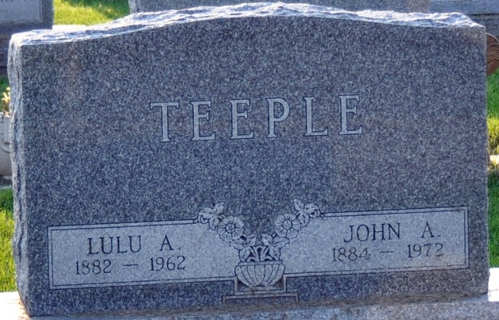
Photo by Deb Curry

JOHN A. TEEPLE DIES THIS MORNING
John A. Teeple, 87, of Decatur route 5, died at 7:45 a.m. today at the Adams County Memorial Hospital. He had been ill for the past month and hospitalized for two days.
Born in St. Mary's Township Aug. 16, 1884, he was a son of William H. and Rosetta Gulick Teeple and was married to Lulu A. Davidson April 29, 1950. His wife preceded him in death Dec. 25, 1962.
Mr. Teeple was a civil engineer in Oregon and Washington and was also a former employe of Teeple Trucking Co. He was a member of Decatur Masonic Lodge 571.
Surviving is a sister, Mrs. Joe (Mamie) Brookhart of Decatur route 5; and three brothers, William G. Teeple of Decatur route 3, Benjamin W. Teeple of Woodland, Calif., and Donald Teeple of Fort Wayne. One brother and one sister are deceased.
Funeral services will be conducted at 1:30 p.m. Tuesday at the Zwick Funeral Home, with Rev. David Murray officiating. Burial will be in the Decatur Cemetery. Friends may call at the funeral home after 12 noon Monday until time of the services.
Decatur Daily Democrat, Adams County, Indiana
Saturday, March 25, 1972

