Jay H. Teeple
September 22, 1895 – November 4, 1964

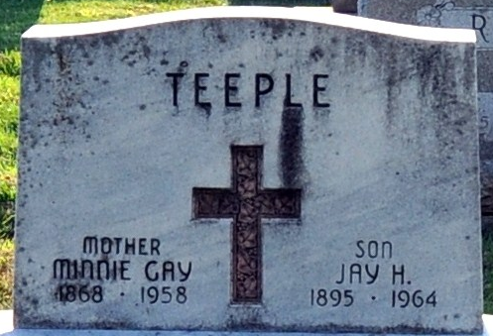
Photo by Deb Curry

Jay H. Teeple Dies at Veterans Hospital
Jay H. Teeple, 69, former resident of Decatur, and a veteran of WWI, died at 7 o'clock this morning at the Veterans Hospital at Danville, Ill. Mr. Teeple, who was wounded during the closing week of World War I, had been a patient at the Veterans Hospital for many years.
He was born at Rockford, O., a son of Zachariah and Minnie Gay Teeple, but spent most of his life in Decatur prior to entering army service.
Surviving are three brothers, Max H. Teeple of Bluffton, Jack S. Teeple of Decatur, and John E. Teeple of Maumee, O., and two sisters, Mrs. J.E. (Nellie) Rutledge of Lima, O., and Mrs. Lillie DeWitt of Bristol Village, O.
Funeral rites will be conducted at 3:30 p.m. Saturday at the Zwick funeral home, with the Rev. Fuhrman Miller officiating. Burial will be in the Decatur Cemetery, with military rites at graveside by the American Legion. Friends may call at the funeral home after 6 p.m. Friday until time of the services.
Decatur Daily Democrat, Adams County, Indiana
Wednesday, November 4, 1964
**
Max H. Teeple's Brother Dies at 69
Jay H. Teeple, 69, former resident of Decatur and a brother of Max H. Teeple of Bluffton, died at 7 a.m. Wednesday at Veterans Hospital in Danville, Ill., where he had been a patient many years.
Other survivors include two brothers, Jack S. of Decatur and John E. of Maumee, O., and two sisters, Mrs. J.E. Rutledge of Lima, O., and Mrs. Lillie DeWitt of Bristol Village, O.
The body is at the Zwick Funeral Home in Decatur, where services will be held at 3:30 p.m. Saturday. Burial will be in Decatur Cemetery with military rites at the graveside by the American Legion.

Bluffton News Banner, Wells County, Indiana
Thursday, November 4, 1964

