Jack S. Teeple
October 11, 1905 – November 1982

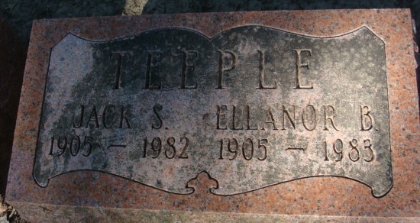
Photo by Alicia Kneuss

Collection: Ohio Births and Christenings, 1821-1962
Name: Jack S. Teeple; Gender: Male
Birth Date: 11 Oct 1905; Birthplace: Rockford, Mercer, Ohio
Father's Name: Z. T. Teeple; Mother's Name: Minnie E. Gay
Indexing Project (Batch) Number: I08975-2; System Origin: Ohio-EASy; Source Film Number: 914953; Reference Number: p 140
**
SSDI: Jack Teeple; xxx; Last Residence: 85364 Yuma, Yuma, Arizona; Born: 11 Oct 1905 Died: Nov 1982 State (Year) SSN issued: Indiana (Before 1951)
**
Jack S Teeple from tree Tooley Family Tree
Birth 11 Oct 1905 Ohio, USA
Residence 1940 Decatur, Adams, Indiana, USA
Death Nov 1982 Yuma, Yuma, Arizona, USA
Father Zachariah Taylor Teeple (1860-1907)
Mother Minnie Estella Gay (1868-1958)
Spouse Ellanor Burdge Ellis (1905-1983)

