Iva A. (Barrone) Teeple-Hunter
November 20, 1902 – December 9, 1981

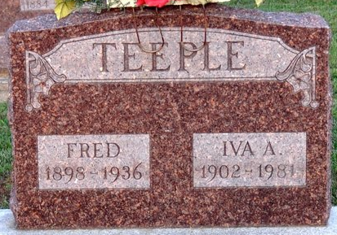
Photo by Deb Curry

Iva A. Hunter
in the Indiana, U.S., Death Certificates, 1899-2017
Name Iva A. Hunter
[Iva A. Barrone]
Gender Female
Race White
Marital Status Widowed
Age 79
Birth Date 20 Nov 1902
Birth Place Indiana
Death Date 9 Dec 1981
Death Place Decatur, Adams, Indiana, USA
Death Registration Date 1981
Father John Barrone
Mother Rosa Geier
Informant Maurice E. Teeple; Decatur, Indiana
Burial December 12, 1981; Decatur Cemetery; Decatur, Indiana

