Henry Irvin Teeple
August 18, 1859 – June 19, 1929

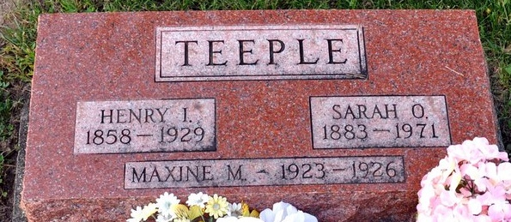
Photo by Deb Curry

Henry Erwin Teeple
in the Indiana, U.S., Death Certificates, 1899-2017
Name Henry Erwin Teeple
Gender Male
Race White
Marital Status Married
Age 69
Birth Date 18 Aug 1859
Birth Place Iowa
Death Date 19 Jun 1929
Death Place Blue-Creek, Adams, Indiana, USA
Death Registration Date 1929
Father Samuel Teeple
Mother Laura Acker
Spouse Oliva Marsh
Informant John Teeple; Monroe, Indiana
Burial June 22, 1929; Decatur Cemetery

