Harvey Judson Teeple
April 22, 1883 – August 22, 1961

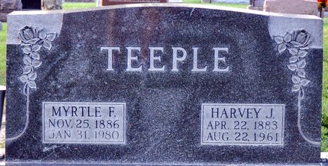
Photo by Deb Curry

Harvey J. Teeple Dies Last Night
Harvey Judson Teeple, 78, of 713 North Third Street, well known Decatur resident, died at 10:50 o'clock Tuesday night at the Adams County Memorial Hospital following an illness of only one day.
Mr. Teeple was a telegrapher for the Erie Railroad for 52 years until his retirement June 24, 1954.
He was born in St. Mary's Township April 22, 1883, a son of Zack and Jane Cramer-Teeple, and was married to Myrtle Snead Aug. 18, 1908.
Mr. Teeple was a member of the Loyal Order of Moose, Ben Hur, Railroad Veterans Association and the Order of Railroad Telegraphers.
Surviving in addition to his wife are two daughters, Misses Gladys and Belva Teeple, both at home; four half-brothers, Jack Teeple of Decatur, Max Teeple of Bluffton, Jay Teeple of Danville, Ill., and John Teeple of Maumee, O., and two half-sisters, Mrs. Nellie Rutledge of Lima, O., and Mrs. Lillie DeWitt of Indianapolis.
Funeral services will be conducted at 2 p.m. Friday at the Zwick Funeral Home, the Rev. Kenneth Angle officiating. Burial in the Decatur Cemetery. Friends may call at the funeral home after 7 p.m. today until time of the services. The Moose Lodge will hold memorial services at 7:30 p.m. Thursday.
Decatur Daily Democrat, Adams County, Indiana
Wednesday, August 23, 1961

