Goldie Jeanette (Franz) Teeple
October 31, 1920 – November 9, 2003

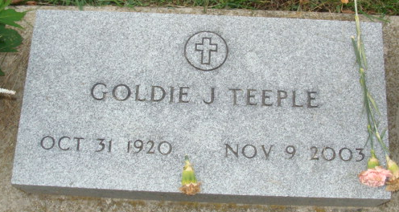
Photo by Alicia Kneuss

Goldie J. Teeple, 83, of Bradenton, died Nov. 9, 2003.
Born Oct. 31, 1920 in Monroeville, IN, she moved to Bradenton in 1985 from Wolcottville, IN.
A memorial service will be held in Decatur, IN at a later date. Brown & Sons Funeral Homes, 26th St. Chapel in charge of local arrangement

Bradenton Herald, Bradenton, Florida
November 11, 2003
**
Goldie J. Teeple, 83, Bradenton, died Nov. 9, 2003. She was born Oct. 31, 1920, in Monroeville, Ind., and came to Manatee County in 1985 from Wolcottville, Ind. She was a homemaker. She was a Methodist.
Survivors include a daughter, Cindy Roberts of Wolcottville; sons Steve of Bradenton and Jeff of LaOtto, Ind.; a sister, Fern Painter of Fort Wayne, Ind.; eight grandchildren; and five great-grandchildren.
No visitation is scheduled. A memorial service will be later in Decatur, Ind. Brown and Sons Funeral Home, 26th Street Chapel, is in charge.
Memorial donations may be made to the American Heart Association, Attn: Memorials, P.O. Box 21475, St. Petersburg, FL 33742.

Sarasota Herald-Tribune, Sarasota, Florida
November 11, 2003
**
Goldie Jeanette Franz from tree Emerson Family Tree
Birth 31 Oct 1920 Monroeville, Allen, Indiana, USA
Residence 1991 Bradenton, Manatee, Florida, USA
Death 9 Nov 2003 Bradenton, Manatee, Florida, USA
Father Frederick Christian Louis Franz (1884-1970)
Mother Erma Clyo Barkley (1894-1961)
Spouse Julius F. Teeple (1916-1985)

