Gladys C. Teeple
October 10, 1909 – July 28, 2004

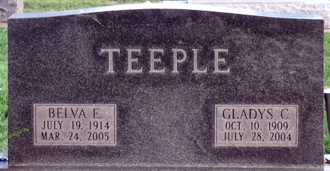
Photo by Deb Curry

Gladys C. Teeple, 94 years old of Decatur, Indiana, passed away at 9:05 a.m. on Wednesday, July 28, 2004 in the Woodcrest Nursing Center, of Decatur, Indiana, where she was a resident for several years.
Gladys was born on October 10, 1909 in Adams County, Indiana, the Daughter of the late Harvey J. Teeple and the late Myrtle F. Stead. She was never married.
Gladys was a member of the First United Methodist Church in Decatur, Indiana. Gladys retired in 1950 from Citizens Telephone Company and was also a former employee of General Electric of Decatur, Indiana.
Surviving is her sister, Belva E. Teeple of Decatur, Indiana.
Funeral services will be held at 1:00 p.m. Saturday, July 31, 2004 in the Zwick & Jahn Funeral Home with the Rev. Loren Felabom officiating. Interment will follow in the Decatur Cemetery. Friends will be received from 11:00 a.m.- 1:00 p.m. Saturday, July 31, 2004 in the Zwick & Jahn Funeral Home, Decatur, Indiana.
Preferred memorials are to the First United Methodist Church, Decatur.

Zwick & Jahn Funeral Home, Adams County, Indiana
July 29, 2004

