Fred Teeple
November 10, 1898 – December 30, 1936

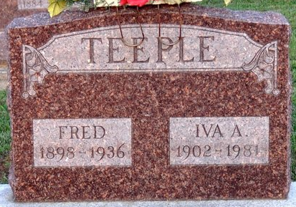
Photo by Deb Curry

DECATUR, Dec 31. - Fred Teeple, 38, General Electric worker living east of Decatur, died at the Lutheran hospital in Fort Wayne Wednesday night. Death was caused by acute heart dilation.
The deceased was born in Decatur November 10, 1898, the son of William and Ollie Teeple. He married Iva Barrone September 13, 1924.
Surviving is the widow; the father; two sons, Maurice and James; three sisters, Mrs. George Davis of Albuquerque, N. M., Mrs. Bruce Conway of Cedarville and Mrs. Noah Sheets of Decatur.
Funeral services will be held at the home at 1:30 p.m. Saturday and at 2 o'clock at the First Evangelical Church. Burial in the Decatur Cemetery.

Journal Gazette, Allen County, Indiana
Friday, January 1, 1937
**

Index to Birth Records, 1882 - 1920 Inclusive, Volume I, Letters A - Z Inclusive; Book: H-6 Page: 11
Name: Teeple
Father: Wm B
Mother: Aly Hollopeter
County: Adams
Gender: M
Birth Date: 10 Nov 1898

