Emma Estella Teeple
July 28, 1873 – August 16, 1873

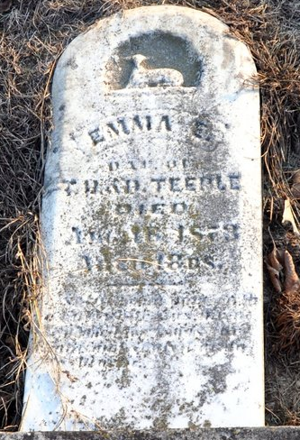
Photo by Deb Curry

Emma Estella Teeple from tree Beemer/Wagner and Related Ancestor Trees
Birth 28 Jul 1873 Harrison, Van Wert, Ohio, USA
Death 16 Aug 1873 Harrison, Van Wert, Ohio, USA
Father Thomas H Teeple (1847-1917)
Mother Delana Teeple (1845-1911)

