Ellanor B. (Ellis) Teeple
April 11, 1905 – December 12, 1983

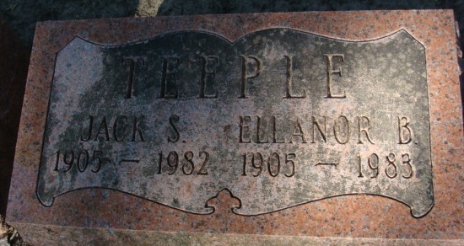
Photo by Alicia Kneuss

Ellanor B. Teeple
in the Indiana, U.S., Death Certificates, 1899-2017
Name Ellanor B. Teeple
[Ellanor B. Ellis]
Gender Female
Race White
Age 78
Marital Status Widowed
Birth Date 11 Apr 1905
Birth Place Indiana
Death Date 12 Dec 1983
Death Place Ossian, Wells, Indiana, USA
Death Registration Date 1983
Father: Lafayette Ellis
Mother: Bertha Burdg
Informant: Patsy Schoenherr; niece; Fort Wayne, Indiana
Cremated: December 15, 1983; Meeks Mortuary; Muncie, Indiana

