Elizabeth (Smith) Teeple
1841 – March 22, 1896

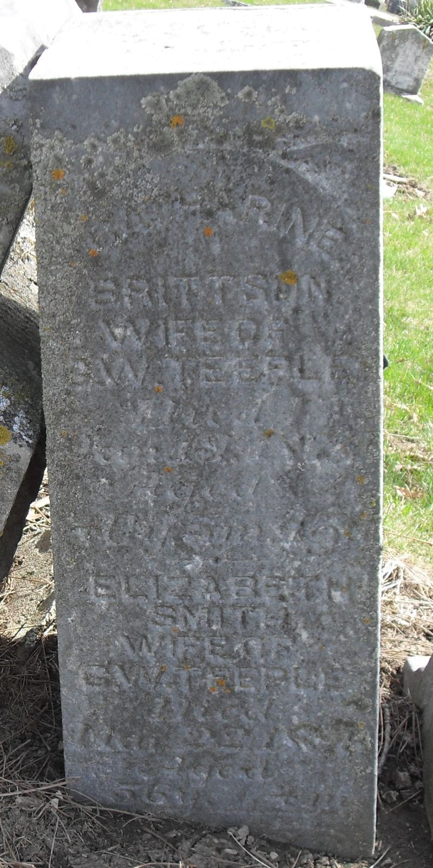
Photo by Deb Curry

Will of Elizabeth Teeple
Name in Record Reason for Being in Record Date of Record
Elizabeth Teeple; Of Decatur; makes her last will & testament; Jan. 29, 1896
George W. Teeple Husband; Inherits real estate in Decatur
Unnamed brothers; To select white granite marble monument for burial in Maplewood Cem.
William B. Teeple Inherits 100.00
Louisa Westerfield Nee Teeple; inherits 100.00
Emma A. Teeple Inherits 100.00
George W. Smith Brother; inherits 100.00
Philip Smith Brother; inherits 100.00
Charles M. Tussing Nephew; inherits balance of estate
John H. Lenhart Appointed executor of will of Elizabeth Teeple
Sylvester Spangler; Appointed executor if replacement executor is necessary
James T. Merryman; Witnessed Elizabeth Teeple making her last will
Sylvester Spangler; Witnessed Elizabeth Teeple making her last will
Elizabeth Teeple Died March 22, 1896
James T. Merryman; Subscribing witness; oath of death & validity of will; March 27, 1896
John H. Lenhart; Clerk; will has been admitted to probate; March 27, 1896
**
Elizabeth Smith Teeple from tree SMITH Family Tree
Birth 1840 Fairfield, Butler, Ohio, USA
Residence 1880 Decatur, Adams, Indiana, USA
Marriage 7 Oct 1897 Adams, Berkshire, Massachusetts, USA
Death 22 Mar 1896 Allen, Indiana, USA
Father Frederick John SMITH (1813-1896)
Mother Christena LENDERMUTER (1819-1886)
Spouse George Washington Teeple (1834-1916)

