Della S. (Cook) Teeple
March 4, 1883 – August 22, 1956

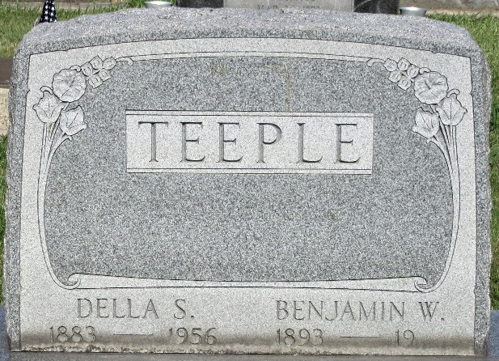
Photo by PLS

Mrs. Ben Teeple Ends Life in Cistern Today
Ill Health Believed to Have Been Cause; Funeral on Friday
Mrs. Della Teeple, 73, wife of Ben Teeple, died this morning by drowning in a cistern at her home a mile north and two miles west of Monroe, at the former Debolt School. Sheriff Merle Affolder, who investigated and who removed the body from the pool, stated that the death would be recorded as a suicide.
Mrs. Teeple had not been well, and the cause of her act is attributed to despondency over ill health. She had gotten up from bed about 3 o'clock this morning, the sheriff stated he was informed by the husband, but who thought nothing of it. At 5 o'clock when he awoke, he noticed that she was not in bed. Upon investigation he discovered that she left a note on the kitchen table indicating her intentions.
Her husband taught school for a number of years in Monroe and Blue Creek Townships and in other schools in northern Adams County.
The deceased was born in Harrison Township, Van Wert County, Ohio, on March 4,1883, the daughter of Thomas and Barbara Finkhousen Cook. She was married to Dore W. Debolt in September 1902. Mr. Debolt passed away in 1930. On December 24, 1938 she was married to Ben W. Teeple who survives.
She is survived by the following children by her first marriage: Mrs. Andrew Baker, Mrs. Lawrence Springer, both of Decatur, Chester Debolt of Ridgeville; Mrs. Kenneth Sacaure of Decatur, Mrs. Frank Grice of Wren, Ohio and Kenneth L. Debolt of Decatur. Also the following step-children (missing).
Adams County Historical Museum, Adams County, Indiana
March 1955 – April 1958 Scrapbook
Handwritten date: Wednesday, August 22, 1956
**

Mrs. Della Teeple Dies Early Today
Farm Woman Takes Life By Drowning

Mrs. Della S. Teeple, 73, a resident of Washington township and wife of Benjamin W. Teeple, took her life early this morning at her farm home two miles west and one mile north of Monroe. County coroner Harmon H. Gillig ruled that death was caused by drowning and that it occurred sometime between 3 and 4 a.m. today. Members of the family discovered her body in a cistern at about 5 a.m. She had been in ill health for some time.
A native of Harrison township in Van Wert County, O., she was born March 4, 1883, to Thomas and Barbara Finkhousen-Cook. She was married in September 1902, to D. W. DeBolt who preceded her in death. She was then married Dec. 24, 1938, to Benjamin Teeple who survives. She has resided in this county for many years.
Surviving in addition to her husband are two sons, Chester F. DeBolt of Ridgeville and Kenneth L. DeBolt of Decatur; four daughters, Mrs. Andrew Bailey, Mrs. Lawrence Springer and Mrs. Kenneth Secaur, all of Decatur and Mrs. Frank Grice of Wren, O; three step-children, Mrs. Herbert Fenster of Orland, Fla., Mrs. Milton Helmke of Fort Wayne and Morton W. Teeple of Houston, Tex.; 15 grandchildren; nine great grandchildren; seven step-grandchildren; one brother, Otto Exley of Decatur, and two sisters, Mrs. Chauncy Cox and Mrs. Louis Cortney, both of Van Wert, O. Two brothers preceded her in death.
Funeral services will be conducted Friday at __ p.m. at Black's Funeral Home with the Rev. John Chambers officiating. Burial will be in the Decatur Cemetery. Friends may call at the funeral home after 7 o'clock this evening.

Decatur Daily Democrat, Adams County, Indiana
Wednesday, August 22, 1956

