Delana (Springer) Teeple
July 25, 1845 – October 20, 1911

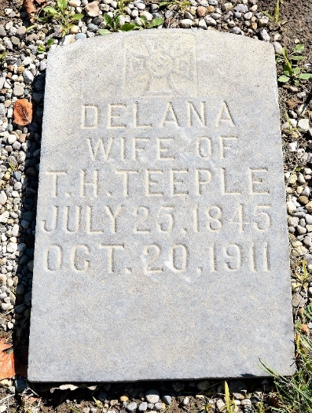
Photo by Richard Roop

Yesterday at fifteen minutes to 12 o'clock a useful and beloved life was closed when Mrs. Delany Teeple, wife of Thomas Teeple, passed away. Following a complication of sicknesses of several months, death came as a relief.
The deceased was born in Fairfield County, Ohio, on July 25, 1845, the daughter of Henry and Margaret Springer. On Thanksgiving day, 1886, her marriage to Thomas Teeple, of Decatur, took place at Willshire, Rev. Baxter solemnizing the event. The couple came to Decatur to live and where they have in the years since been highly honored and respected. To the union nine children were born, five of whom are dead.
The surviving children are: D. J. Teeple of this city, Anna J. Gamble, Harriet M. Rose and Ida M. Denton of Huntington.
Fort Wayne Sentinel, Allen County, Indiana
Saturday, October 21, 1911
**
Indiana, U.S., Death Certificates, 1899-2017
Name Delaney Teeple
[Delaney Springer]
Gender Female
Race White
Marital Status Married
Age 66
Birth Date 25 Jul 1845
Birth Place Fairfield Co Ohio
Death Date 20 Oct 1911
Death Place Decatur, Adams, Indiana, USA
Father Henry Springer
Mother Madaline Fast
Spouse Thomas Henry Teeple
Informant Thomas Teeple; Decatur, Indiana
Burial October 23, 1911; Decatur Cemetery

