Deborah Kay Teeple
May 11, 1953 – February 11, 1957

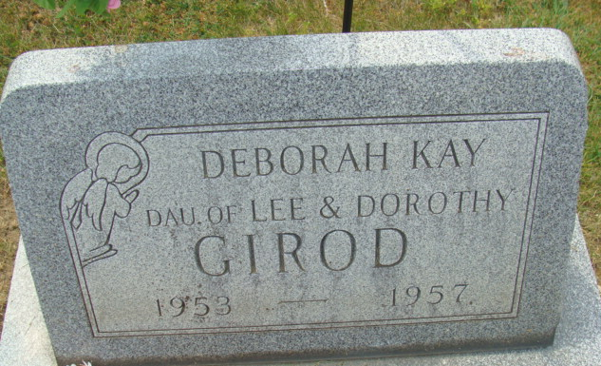
Photo by Alicia Kneuss
Deborah K. Teeple Killed In Accident
Child Dies Monday Of Fractured Neck
Deborah Kay Teeple, three-year-old granddaughter of Mr. and Mrs. M. S. Welker of 615 Indiana Street, was killed in an automobile accident Monday, two miles east of Scottsburg on State Highway 56. The child was a passenger in a car driven by her stepfather, Lee Girod of Scottsburg Route Three. The Girod car was passing a truck when it hit the berm and went out of control. The vehicle overturned and Deborah was thrown out, suffering a fractured neck, which caused her death. Girod and two brothers and a sister of the child escaped serious injury.
The girl was born in Decatur May 11, 1953, to Albert Teeple and Dorothy Welker Teeple Girod.
Surviving are her parents, her stepfather, two brothers and a sister, and her maternal grandparents. Funeral services will be conducted Thursday in Decatur, but arrangements have not been completed. Friends may call at Zwick Funeral Home after 7 o’clock this evening.
Decatur Daily Democrat; Adams County, Indiana
Tuesday, February 12, 1957
**

Indiana, U.S., Death Certificates, 1899-2011
Name: Deborah Kay Teeple
Gender: Female; Race: White; Age: 3
Marital status: Never Married (Single)
Birth Date: 11 May 1953
Birth Place: Indiana
Death Date: 11 Feb 1957; auto accident
Death Place: Scottsburg, Scott, Indiana, USA
Father: Albert Teeple
Mother: Dorothy Welker
Informant: Lee Girod; stepfather; Scottsburg, Indiana
Removal: December 12, 1957; Decatur, Indiana

