Charlie D. Teeple
December 15, 1871 – January 11, 1951

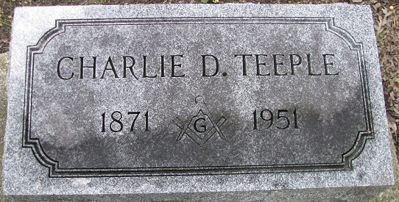
Photo by PLS

Charles D. Teeple Is Taken By Death
Former Businessman Of Decatur Is Dead
Charles D. Teeple, 79, for many years a Decatur clothing merchant. and prominent churchman, died at St. Joseph, Mich. Thursday afternoon at 4 o'clock. The Teeples had moved to St. Joseph last summer. Death resulted from a combination of ailments and Mr. Teeple had been bedfast most of the time since moving to the Michigan city.
Charles D. Teeple, was born in Willshire, O., December 15, 1871, a son of Andrew J. and Achsah [Thompson] Teeple. He was married May 26, 1898, to Margaret Fordyce. The Teeples resided in Decatur all of their married life until last summer.
Mrs. Teeple and a daughter, Mrs. Alta McClintock of Benton Harbor, Mich., and three grandchildren, Andrew Fordyce McClintock, Joan and Susan McClintock, also of Benton Harbor, survive.
Mr. Teeple was engaged in the clothing business here for years, being the senior partner in the firm of Teeple, Brandyberry and Peterson. The store later became Teeple and Peterson and a few years ago when Mr. Teeple retired, the store became Peterson’s and is now Peterson and Heller.
He was active for years in the First Presbyterian Church and the Decatur Masonic Lodge, being a 50-year member of the local lodge. He served several terms as elder of the Presbyterian Church and also taught in the Sunday School. He was active in Decatur and Adams County church affairs.
The body will be brought to the Black Funeral Home in Decatur late Saturday afternoon. Friends may call Sunday and Monday until noon. Funeral services will be held at the First Presbyterian Church Monday afternoon at 2 o’clock with the Rev. A. C. E. Gillander, pastor of the First Presbyterian church in charge, assisted by the Rev. Lawrence T. Norris, pastor of Union Chapel Evangelical United Brethren Church, a close personal friend of Mr. Teeple.
Active pallbearers will be Leonard Soliday, Roscoe Glendening, Dick Heller, Sim Burk, M. A. Frisinger and Ed F. Jaberg. Honorary pallbearers will include John H. Heller, W. F. Beery, Fred V. Mills, Charles Knapp, Wilson Lee and Cal E. Peterson, partner of Mr. Teeple, during his years in the clothing business. Burial will be in the Decatur Cemetery.
Decatur Daily Democrat; Adams County, Indiana
Friday, January 12, 1951

