Catharine (Brittson) Teeple
August 4, 1838 – January 19, 1879

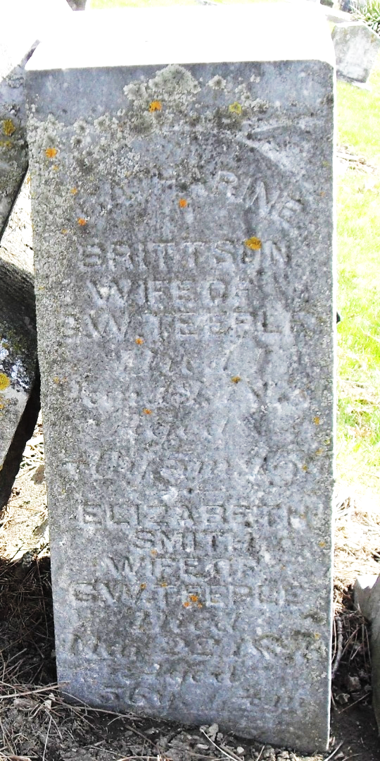
Photo by Stephen & Andrea Brangan

Catharine Brittson from tree Griffiths Family Tree
Birth 4 Aug 1838 Adams, Indiana, USA
Marriage 2 Apr 1857 Adams, Indiana, USA
Residence 1870 Allen, Indiana, USA
Death 19 Jan 1879 Decatur, Adams, Indiana, USA
Father Isaac Brittsan (1787-1842)
Mother Martha Watkins Archibald (1794-1872)
Spouse George Washington Teeple (1834-1916)

