Benjamin B. Teeple
January 5, 1867 – November 24, 1938

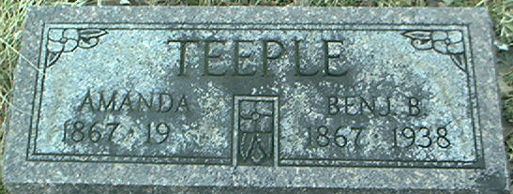
Photo by Teresa Davis

Benjamin B. Teeple
Death • Ohio, County Death Records, 1840-2001
Name Benjamin B. Teeple
Sex Male
Age 71y 10m 19d
Birth Date 05 Jan 1867
Birthplace Adams Co., Indiana
Residence Place Wren, Ohio
Burial Date 26 Nov 1938
Cemetery Decatur Cem.
Marital Status Married
Occupation Retired
Race White
Father's Name John Teeple
Father's Birthplace Ohio
Mother's Name Catherine Smith
Mother's Birthplace Indiana
Spouse's Name Amanda Green
Event Type Death
Event Date 24 Nov 1938
Event Place Wren, Willshire Township, Van Wert, Ohio, United States
Event Place (Original) Wren, Willshire Twp., Van Wert, Ohio
Informant Mrs. Ben Teeple; Wren, Ohio
Source Details item 5 cn 76

