Belva E. Teeple
July 19, 1914 – March 24, 2005

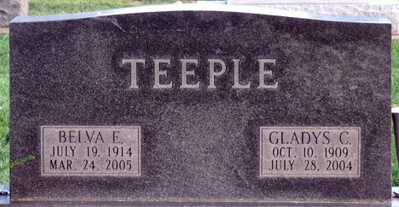
Photo by Deb Curry

Belva E. Teeple, 90 years old of Decatur, Indiana, passed away at 7:35 p.m. on Thursday, March 24, 2005 in the Woodcrest Nursing Center located in Decatur, Indiana.
Belva was born on July 19, 1914 in Adams County, Indiana, the daughter of the late Harvey J. Teeple and the late Myrtle F. (Stead) Teeple. She was never married.
Belva was a member of First United Methodist Church in Decatur, Indiana. Belva was a clerk at the Vitz Gift Shop and various other places.
There are no known survivors. Belva was preceded in death by one sister, Gladys Teeple.
Funeral services will be held at 4:00 p.m. Saturday, March 26, 2005 in the Zwick & Jahn Funeral Home Interment will follow in the Decatur Cemetery. Friends will be received from 3:00 p.m.- 4:00 p.m. Saturday, March 26, 2005 in the Zwick & Jahn Funeral Home, Decatur, Indiana.
Preferred memorials are to the First United Methodist Church in Decatur, Indiana.

Zwick & Jahn Funeral Home, Adams County, Indiana
March 25, 2005

