Amanda (Green) Teeple
July 29, 1865 – October 29, 1952

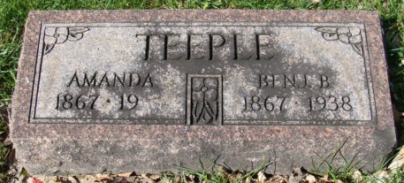
Photo by Alicia Kneuss

Amanda Teeple
in the Indiana, Death Certificates, 1899-2011
Name: Amanda Teeple
[Amanda Green]
Gender: Female
Race: White
Age: 87
Marital status: Widowed
Birth Date: 29 Jul 1865
Birth Place: Crawford Co, Ohio
Death Date: 29 Oct 1952
Death Place: Decatur, Adams, Indiana , USA
Father: John Green
Informant: Mr. Earl Shoaf; Decatur, Ind.
Burial: Oct. 31, 1952; Maplewood Cem., Decatur, Ind

