Albert C. Teeple
August 5, 1893 – September 6, 1980

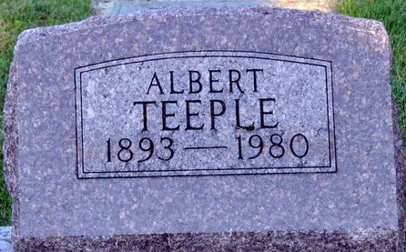
Photo by Deb Curry

Albert Teeple Dies at Age 87; Services Monday
Retired farmer and former resident of Craigville Route 1, Albert C. Teeple, 87, died at 5:45 p.m. Friday at the Colonial Crest Convalescent Center in Fort Wayne where he had resided the past three years.
Mr. Teeple, a veteran of World War 1, and was a member of the VFW and DAV at Lima, OH. Born Aug. 5, 1893, in Ohio, he was a son of Henry and Rebecca Miller Teeple.
Surviving are four sons, Raymond D. Teeple of Craigville Route 1, Robert M. Teeple of Decatur, Wayne Teeple of Decatur Route 1 and Albert Teeple Jr. of Fort Wayne; five daughters, Mrs. William (Jessie) Grepke, Miss Patricia Teeple and Mrs. John (Geraldine) Lauck, all of Fort Wayne, Mrs. Ora (Esther) Adams of Berne, Route 2 and Mrs. Walter (Zella) Haines of Decatur Route 2; a half-brother, Harvey Teeple of Bern Route 1, 28 grandchildren and 21 great-grandchildren.
Calling at the Winteregg-Linn and Haggard Funeral Home in Decatur will be from 2 to 5 and 6 to 9 p.m. Sunday and after 12:30 p.m. Monday until time for services there at 3 p.m. Rev. Edison Reynolds will be in charge of the services and burial will be in the Decatur Cemetery.
News Banner, Wells County, Indiana
September 6, 1980
**

Indiana Marriage Collection, 1800-1941

Name: Albert Teeple
Spouse Name: Leona Bartling
Marriage Date: 30 Jun 1917; Marriage County: Adams

Adams County, Indiana Index to Marriage Records 1845 - 1920 Inclusive Vo; W. P. A. Original Record Located County Clerks Off ; Book: K, OS Page: 239

