LeRoy M. Taylor
March 26, 1882 – July 3, 1962

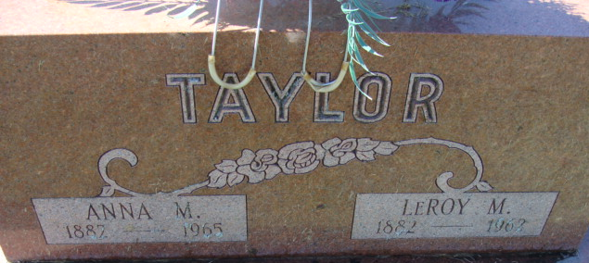
Photo by Alicia Kneuss

LeRoy M. Taylor Dies Unexpectedly
LeRoy M. Taylor, 80, a resident of Decatur for the past 22 years, died suddenly of a heart attack at 10 o'clock this morning at his home, 503 North Seventh Street. Although he had been in failing health for several years, his death was unexpected.
He was born in Freetown March 26, 1882, a son of Samuel and Sarah Taylor, and was married to Anna M. Blum Dec. 25, 1918. A retired farmer and former Phelps-Dodge employee, he lived at Salem for a number of years before moving to Decatur.
Mr. Taylor was a member of the Trinity Evangelical United Brethren Church and the Modern Woodmen Lodge.
Surviving in addition to his wife are two daughters, Mrs. Niles Meddaugh of Van Wert, O., and Mrs. Virginia Raudenbush of Decatur; two sons, the Rev. Mervin Taylor of New Philadelphia, O., and Melvin Taylor of Bayport, Mich.; 11 grandchildren; one brother, Evan Taylor of Saybrook, Ill., and two sisters, Mrs. Frona Bowen and Mrs. Carol Witt, both of Norman, Ill. One son, three brothers and one sister are deceased.
Funeral services will be conducted at 1:30 p.m. Saturday at the Black Funeral Home and at 2 p.m. at the Trinity E.U.B. Church. The Rev. J.O. Penrod will officiate and burial will be in the Decatur Cemetery.
Adams County Historical Museum, Adams County, Indiana
January 1951 – August 1962 Scrapbook, image 71
Handwritten date: Tuesday, July 3, 1962

