Anna M. (Blum) Taylor
December 3, 1882 – May 14, 1965

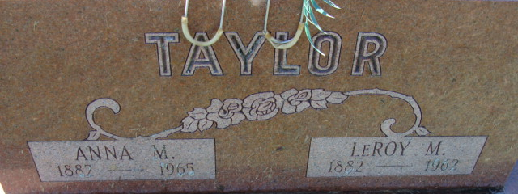
Photo by Alicia Kneuss

Anna Taylor
in the Indiana, U.S., Death Certificates, 1899-2017
Name Anna Taylor
[Anna Blun]
Gender Female
Race Caucasian (White)
Marital Status Widowed
Age 82
Birth Date 3 Dec 1882
Birth Place Illinois
Death Date 14 May 1965
Death Place Decatur, Adams, Indiana, USA
Death Registration Date 1965
Father Balizer Blum
Mother Anna Erion
Informant Mrs. Robert Raudenbush; daughter; Decatur, Indiana
Burial May 17, 1965; Decatur Cemetery; Decatur, Indiana

