Ivle C. Talbott
August 9, 1893 – October 17, 1964

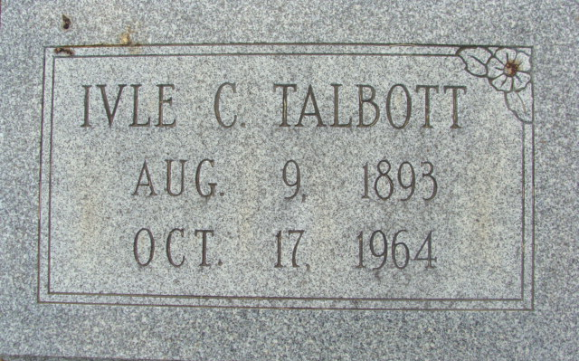
Photo by Alicia Kneuss

Ivle C Talbott
in the Indiana, U.S., Death Certificates, 1899-2017
Name Ivle C Talbott
Gender Male
Race White
Marital Status Married
Age 72
Birth Date 9 Aug 1892
Birth Place Indiana
Death Date 15 Oct 1964
Death Place Decatur, Adams, Indiana, USA
Death Registration Date 1964
Father Charles Talbott
Mother Hattie Metcalf
Informant Myrtle Talbott; wife; Decatur, Indiana
Burial October 18, 1964; Decatur Cemetery; Decatur, Indiana

