William Marion Tague
August 1, 1859 – January 18, 1927

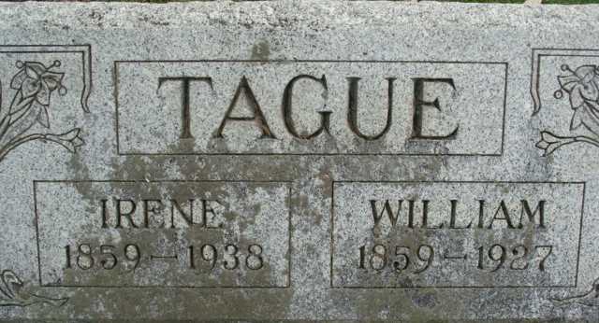
Photo by Alicia Kneuss

William Morion Togue
in the Indiana, U.S., Death Certificates, 1899-2017
Name William Marion Tague
Gender Male
Race White
Marital Status Married
Age 72
Birth Date 1 Aug 1854 [sic]
Birth Place Ohio
Death Date 18 Jan 1927
Death Place Monroe, Adams, Indiana, USA
Death Registration Date 1926-1927
Father John Tague
Mother Susiana Barks?
Spouse Irene
Informant Irene Tague; Monroe, Indiana
Burial January 21, 1927; Decatur Cemetery

