Wayne V. Tague
March 24, 1923 – December 26, 1999

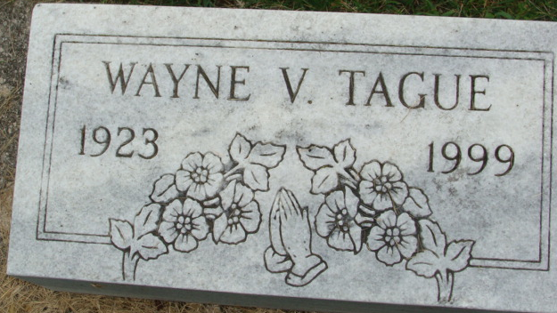
Photo by Alicia Kneuss

Wayne V. Tague, 76, of rural Fort Wayne, a member of Decatur Moose Lodge, died Sunday, Dec. 26, 1999, at Parkview Hospital. The Switzerland County native retired in 1985 from Falstaff Brewery after 21 years of service, had worked for Pennsylvania Railroad for 20 years and was a World War II Army Air Corps veteran.
Surviving is a son, Marvin W. of Decatur; a brother, James of Vevay; a sister, Virginia Tague of Eaton Rapids, Mich.; three grandchildren; and one great-grandchild. He was preceded in death by his wife, Betty J., and two brothers.
Services are 11 a.m. Wednesday at Zwick & Jahn Funeral Home, Decatur, with calling from 6 to 8 p.m. today. Burial will be in Decatur Cemetery.
Memorials are to Adams County Habitat for Humanity.

News-Sentinel, Allen County, Indiana
Tuesday, December 28, 1999

**
Indiana, U.S., Death Certificates, 1899-2017
Name Wayne V. Tague
Gender Male
Race White
Marital Status Widowed
Age 76
Birth Date 24 Mar 1923
Birth Place Switzerland County, Indiana
Death Date 26 Dec 1999
Death Place Fort Wayne, Allen, Indiana, USA
Father William H. Tague
Mother Mary E. Vandever
Informant Marvin Tague; son; Decatur, Indiana
Burial December 29, 1999; Decatur Cemetery; Decatur, Indiana

