Sarah Irene (Baughman) Tague
November 28, 1859 – October 8, 1938

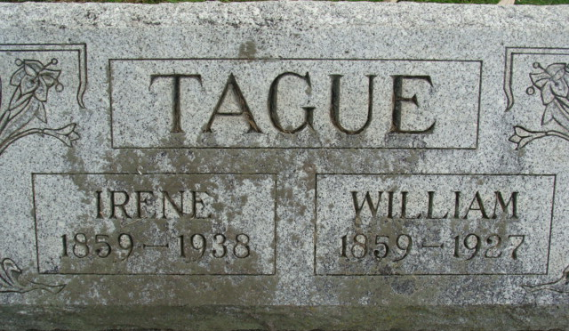
Photo by Alicia Kneuss

Death Claims Sarah Tague
Mrs. Sarah Irene Baughman Tague, 78, died this morning at the home of her daughter, Mrs. Homer Raudenbush, near Decatur.
The deceased was born in ?….ington, Ohio November 28, 1859, the daughter of William and Elizabeth Marks-Baughman.
Death was attributed to complications. She has been ill two years. Her husband, William Tague, preceded her in death in 1927.
Surviving are the daughter and two sisters, Mrs. Mary Pittman of Fort Wayne and Mrs. Adelia Weaver of Manchester, Michigan. The children, one sister and five brothers are deceased.
Funeral services will be held at the home at 1:30, Tuesday afternoon and at 2:00 at Monroe M.E. Church. Burial in Decatur Cemetery. The body will be removed from S.E. Black Funeral Home Monday afternoon to the Raudenbush residence.

Adams County (IN) Historical Museum
1938 Scrapbook, image 81
Saturday, October 8, 1938

