Betty Jean (Jenkins) Tague
November 20, 1924 – March 10, 1977

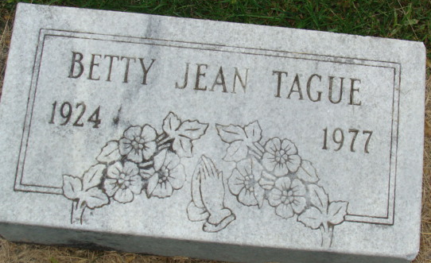
Photo by Alicia Kneuss

Betty Jean Tague
in the Indiana, U.S., Death Certificates, 1899-2017
Name Betty Jean Tague
[Betty Jean Jenkins]
Gender Female
Race White
Marital Status Married
Age 52
Birth Date 20 Nov 1924
Birth Place Indiana
Death Date 10 Mar 1977
Death Place Decatur, Adams, Indiana, USA
Death Registration Date 1977
Father Melvin Jenkins
Mother Edna Smith
Spouse Wayne V. Tague
Informant Wayne V. Tague; husband; Decatur, Indiana
Burial March 13, 1977; Decatur Cemetery; Decatur, Indiana

